**ER Diagram**

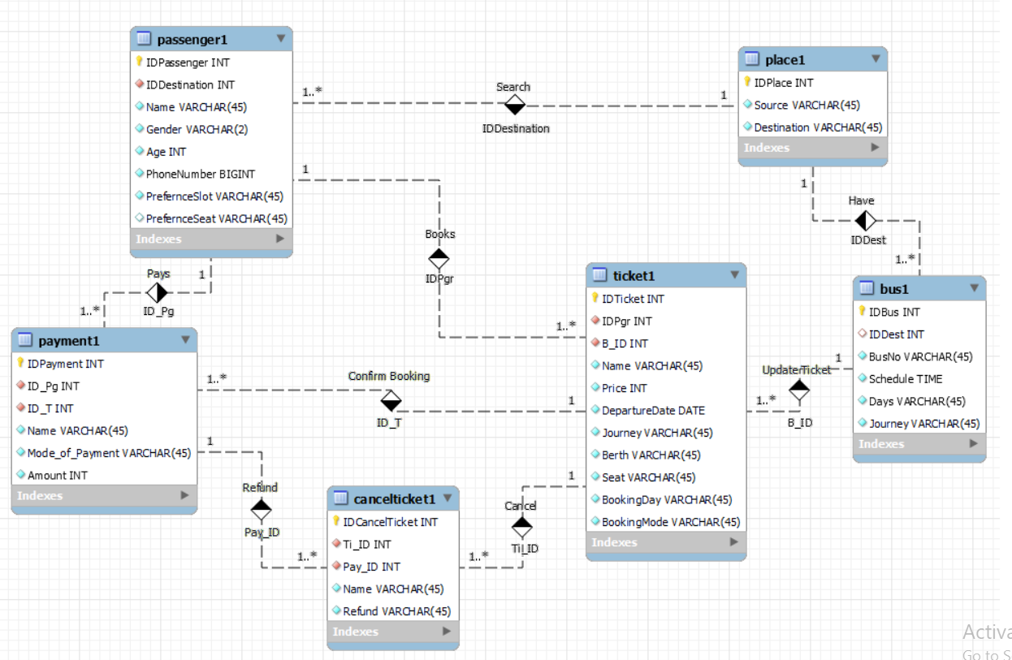

**Schema**

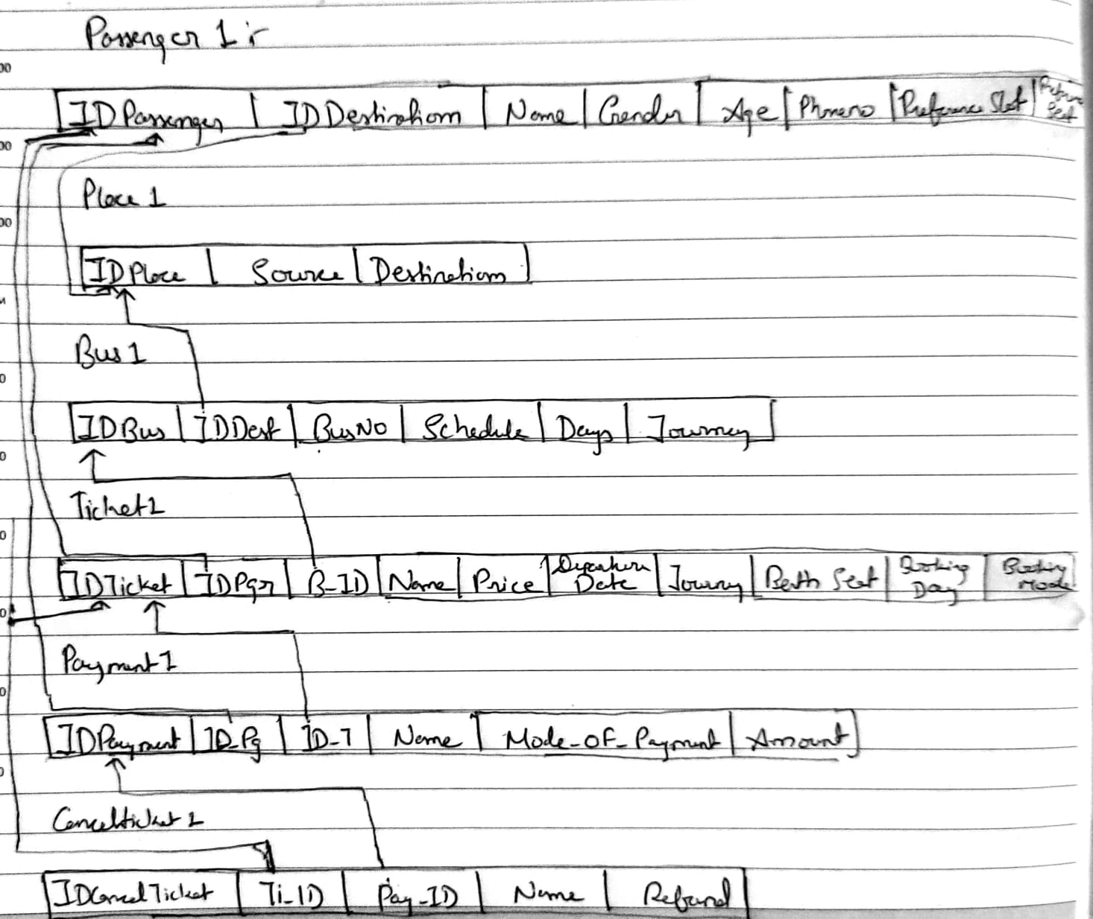

**Tables**

**Passenger1 table**

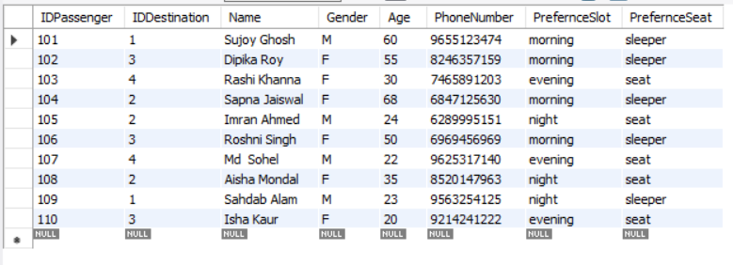

**Bus1 table**

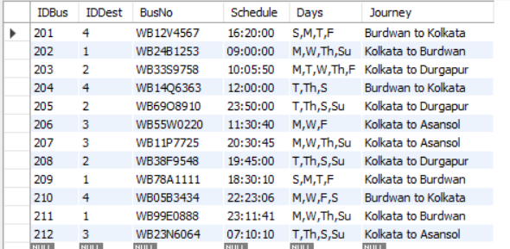

**Place1 table**

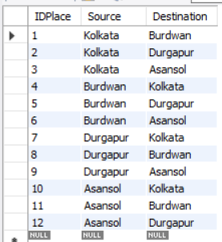

**Ticket1 table**

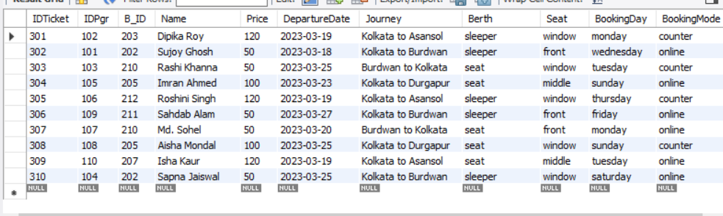

**Payment1 table**

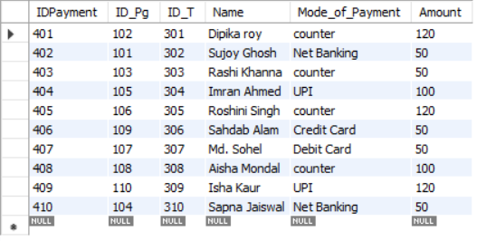

**CancelTicket1 table**

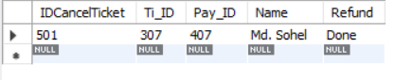

**Queries**

**-- Q1. List the buses from Kolkata to Durgapur**

SELECT * FROM ticket_booking_system.bus1 where journey='Kolkata to Durgapur';

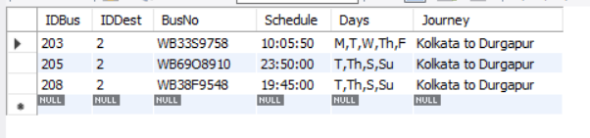

**-- Q2. From 9am to 12 pm ,Find the availability of buses from Kolkata to Burdwan**

SELECT * FROM ticket_booking_system.bus1 where Journey='Kolkata to Burdwan’ and schedule between '09:00:00'and'12:00:00';

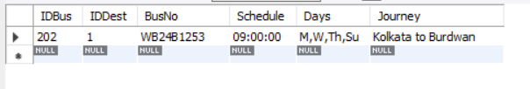

**-- Q3. Find the passengers who booked the ticket for Kolkata to Durgapur on sunday**

SELECT * FROM ticket_booking_system.ticket1 Name where BookingDay='sunday';

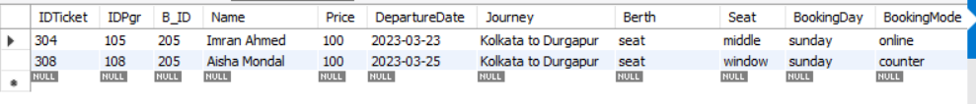

**-- Q4. Find the name started with 'S' who are travelling by bus at 9 am from Kolkata**

SELECT

ticket1.Name ,

bus1.Schedule ,

place1.Source

FROM ticket1

INNER JOIN bus1

ON ticket1.B_ID = bus1.IDBus

INNER JOIN place1

ON bus1.IDDest = place1.IDPlace

where place1.Source='Kolkata' and ticket1.Name like 'S_%' and bus1.Schedule='09:00:00';

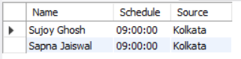

**-- Q5. List the passenger who are more than 60 years prefer to travel in morning**

SELECT * FROM ticket_booking_system.passenger1 Name where age>= 60 and PrefernceSlot='morning';

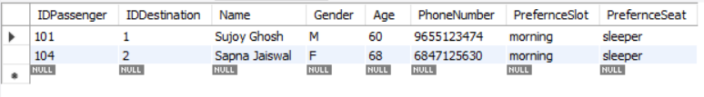

**-- Q6. List the passengers who are travelling from Kolkata to Asansol dated on 19/03/23**

SELECT * FROM ticket_booking_system.ticket1 where Journey='Kolkata to Asansol' and DepartureDate='2023-03-19' ;

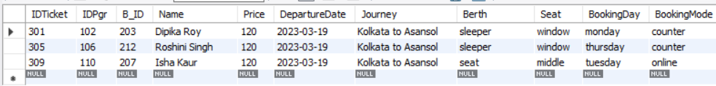

**-- Q7. List the buses which are available between 9:00 am to 12:00 pm for Kolkata to Burdwan.**

SELECT * FROM ticket_booking_system.bus1 where Journey='Kolkata to Burdwan' and schedule between '09:00:00'and'12:00:00';

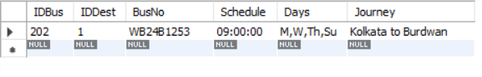

**-- Q8. Count the passengers whose age is more than 50.**

SELECT count(IDPassenger) as no_of_passenger_above_50 from passenger1 where age>=50 ;

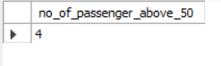

**-- Q9. Count the female passengers who have booked the ticket for 25/03/23 (Calendar Expected date).**

SELECT

ticket1.DepartureDate,

count(passenger1.Gender ) as number_of_females

FROM passenger1

INNER JOIN ticket1

ON passenger1.IDPassenger = ticket1.IDPgr

where ticket1.DepartureDate='2023-03-25';

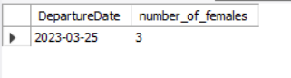

**-- Q10. List the passengers who have booked the ticket from counter for Kolkata to Asansol.**

select * from ticket1 where BookingMode='counter';

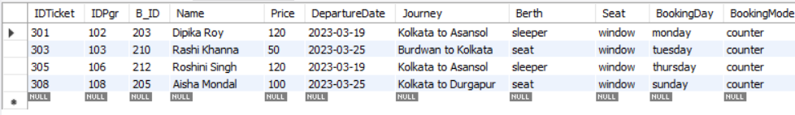

**-- Q11. List the passengers who have booked the ticket for Kolkata to Asansol online mode.**

select * from ticket1 where journey='Kolkata to Asansol' and BookingMode='online';



**-- Q12. List passengers who cancelled the ticket from Burdwan to Kolkata.**

select

cancelticket1.Name,

ticket1.Journey

from cancelticket1

inner join ticket1

on cancelticket1.Ti_ID=ticket1.IDTicket

where ticket1.Journey='Burdwan to Kolkata';

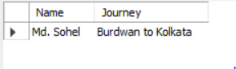

-- **Q13. List the passengers who have booked the ticket for window seat and they are female.**

select

ticket1.Name,

ticket1.Seat,

passenger1.Gender

from ticket1

inner join passenger1

on ticket1.IDPgr=passenger1.IDPassenger

where ticket1.Seat='window'and passenger1.Gender='F';

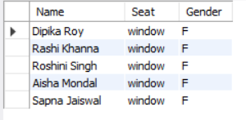

**-- Q14. Count the passengers who booked the ticket through UPI, NET Banking, Counter, and other online modes.**

select count(IDPayment) as NetBanking from payment1

where Mode_of_Payment='Net Banking';



select count(IDPayment) as UPI from payment1

where Mode_of_Payment='UPI';



select count(IDPayment) as Counter from payment1

where Mode_of_Payment='counter';

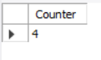

select count(IDPayment) as Credit_card from payment1

where Mode_of_Payment='Credit card';

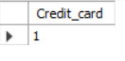

select count(IDPayment) as Debit_card from payment1

where Mode_of_Payment='Debit card';

